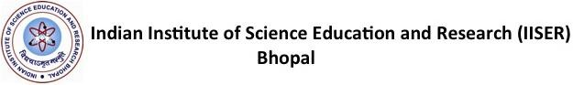
Advertisement for Junior Research Fellow (JRF)in SERB funded research project in the Department of Chemistry at IISER Bhopal
April 10, 2024
Applications are invited from Indian nationals for the post of project-JRF in the research area of Chemical Biology under the DST-SERB Project No SERB/CHM/2023-2024/94.
Project Description: The project will involve synthesis and functionalization of upconversion nanoparticle for activating antibiotics
No. of Position: One JRF.
Duration: Initially 6 months and may be extended depending on performance and availability of funds
Eligibility:
- MSc (or equivalent) in Organic Chemistry/Biochemistry from a recognized University/Institute with a minimum of 60% Marks or CGPA of 7.0 and above at a scale of 10. Prior experience
- Qualified CSIR-UGC NET or GATE with a valid score.
- Candidates should be below 27 years of age at the time of application.
- Candidate should have prior experience in synthetic organic chemistry and molecular biology
Salary: Rs. 37000/- p.m ( consolidated)
How to Apply: Applications containing a detailed CV (including name, photograph, date of birth, address for communication, phone number, email id, details of educational qualifications and name of two referees) should reach the undersigned only by email to: dmanna@iiserb.ac.in
Last date of receiving applications is April 30 ^{th}, 2024.
Shortlisted candidates will be called for an online interview; no TA/DA will be paid for attending the same. Photocopies of certificates/mark sheets and other testimonials will be collected at the time of interview. The selected candidate will be expected to join at the earliest possibility.
Contact Details:
Dr. Debasish Manna
Department of Chemistry
Indian Institute of Science Education and Research (IISER) Bhopal Bhopal By-Pass Road, Bhauri, Bhopal 462066.
Email: dmanna@iiserb.ac.in

